**Feedback Control Systems**

**Lab Report 9**

**Hafiz Ahmad**

**19l-1316**

**Section-6B2**

**QNET DC Motor Position Control**

**INTRODUCTION:**

The physical parameters of a DC motor have already been identified and the mathematical model of it has developed. When the model is confirmed it is utilized to plan a corresponding subsidiary, or PD, regulator that should meet specific given particulars. The DC motor angular position-voltage relation is represented by the transfer function in Equation, which is used to design the PD controller. The information yield connection in the time-space for a PD regulator is u=kp(r y)+ka(bsd r y) Where is the corresponding addition, is the subordinate increase. Similar to the speed control experiment, the standard characteristic function shown in the equation can be achieved by setting the proportional gain to and the derivative gain to respectively. The closed loop transfer function of the motor position system is obtained by combining the position process model with the PD control equation.

**OBJECTIVES:**

• Design a PD controller to regulate the speed of the DC motor

**Procedure:**

Open the QNET_DCMCT_Position _Control.vi. Ensure the correct Device is chosen. Run the QNET_DCMCT_Speed_Control vi. The motor should begin rotating. In the Signal Generator section set: Amplitude = 2.00 rad Frequency = 0.40 Hz Offset = 0.00 rad In the Control Parameters section set: kp= 2.00 V.s/rad ki = 0.00 V/rad kd = 0.00 V/rad. Change the proportional gain, kp, by steps of 0.25 V/rad. Try the following gains kp = 0.5, 1, 2, and 4 V/rad. Examine the behavior of the measured position (red line) with respect to the reference position (blue line) in the Position (rad) scope. Explain what is happening.

|  |  |
| --- | --- |
| Kp=0.5 | Kp=1 |
| Kp=2 | Kp=4 |

Describe the steady-state error to a step input.

When Kp is increased then the oscillations are increasing but error is decreasing.

Increment the derivative gain, kd, by steps of 0.01 V.s/rad. Look at the changes in the measured position with respect to the desired position. Explain what is happening.

|  |  |
| --- | --- |
| Kd=0.02 | Kd=0.07 |

When Kd is increased oscillations are decreasing.

Using the equations calculate and record the expected peak time, tp, and percentage overshoot, PO in Table, given Zeta = 0.60 w0 = 25.0 rad/s p0 = 0.0

|  |  |  |  |
| --- | --- | --- | --- |
| Description | Symbol | Value | Unit |
| Naturel frequency specification | wn | 25 | Rad/s |
| Damping ratio specification | ζ | 0.6 |  |
| Peak time | tp | 0.157 | S |
| Percentage overshoot | PO | 9.48 | % |

Calculate the proportional, , and derivative, , control gains according to the model parameters found in previous experiment and the required specifications and write down theses values in Table

|  |  |  |  |
| --- | --- | --- | --- |
| Description | Symbol | Value | Unit |
| Naturel frequency specification | wn | 25 | Rad/s |
| Damping ratio specification | ζ | 0.6 |  |
| Steady state model gain | K | 30 |  |
| Model time constant | T | 0.061 |  |
| Proportional gain | Kp | 1.2708 |  |
| Derivative gain | kd | 0.027 |  |

Run the QNET_DCMCT_Position_Control.vi. You should see the DC motor rotating back and forth. In the Signal Generator section set: Amplitude = 2.00 rad Frequency = 0.4. Hz Offset = 0.00 rad In the control Parameters section set the PD gains found in Table 9.2. Measure the peak time and percentage overshoot of the measured position response. Are the specifications satisfied? If they are not, then given on possible reason why there would be discrepancy.

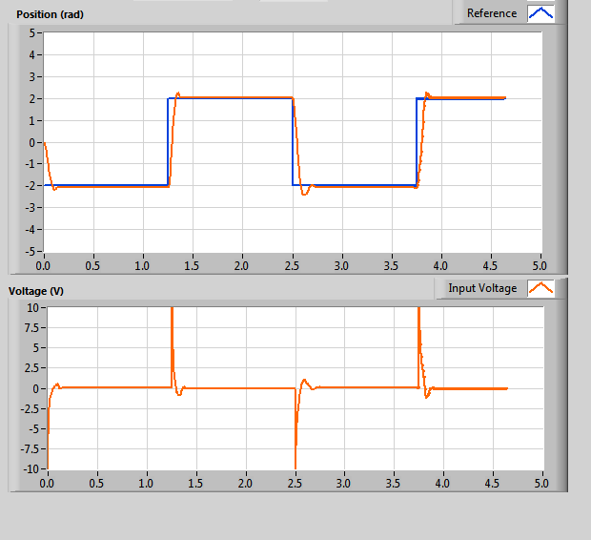

Write down the changing the specification zeta have on the measured position response and the generated control gains

|  |  |  |  |
| --- | --- | --- | --- |
| Description | Symbol | Behaviour | Unit |
| Peak time | Tp | 0.209 | S |
| Percentage overshoot | PO | 1.516 | % |
| Proportional gain | Kd | 1.27 | V.s/rad |
| Derivative gain | kp | 0.048 | V/rad |

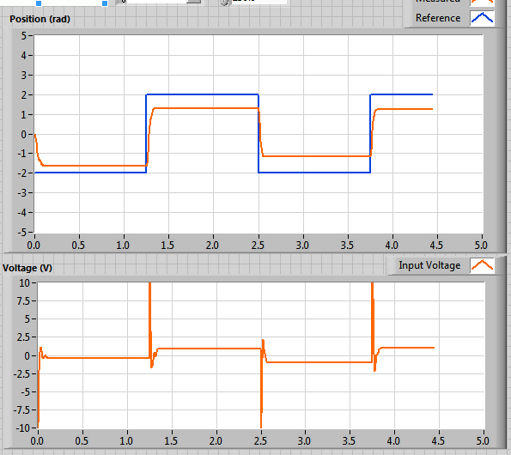

Write down the effect of increasing the specification have on the measured position response and the generated control gains

|  |  |  |  |
| --- | --- | --- | --- |
| Description | Symbol | Behaviour | Unit |
| Peak time | Tp | 0.130 | S |
| Percentage overshoot | PO | 9.47 | % |
| Proportional gain | Kd | 1.83 | V.s/rad |
| Derivative gain | kp | 0.039 | V/rad |

Stop the VI by Clicking on the Stop button.

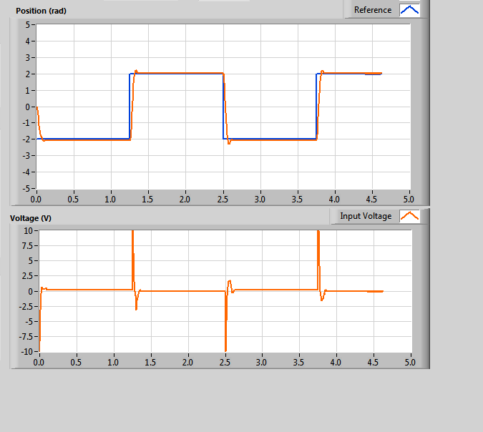

**Application:**

In industrial automatic process control applications, PD controllers are used to regulate variables in industrial processes.

**Issues:**

No issue found while performing in the lab.

**Conclusion:**

From this lab we can plan the PD regulator to control the speed of the engine.

**Post lab:**

1. **Q1What kind of controller is used to control the position of the motor? Give reasons to support your answer.**

Ans: An engine position regulator is utilized. The reason for an engine position regulator is to take a sign addressing the necessary point and to drive an engine at that position. Microcontrollers can give simple control of a DC engine. An electronic component and a microcontroller make up a position control system based on a microcontroller.

1. **Explain the purpose of proportional, integral and derivative gains and how do they affect the position of the motor. You can write the equations to support your answer**

Ans: The ratio of the output response to the error signal is determined by the proportional gain (Kc). A proportional response of 50 would result from a proportional gain of 5 for an error term with a magnitude of 10. By and large, expanding the corresponding addition will speed up the control framework reaction.

When in position control or velocity control, the Integral Gain controls how much of the Control Output is produced by the accumulated Position Error or Velocity Error, respectively. When the Current Control Mode is Position PID, position control is defined.

The subordinate control mode gives a regulator extra control activity when the mistake changes reliably. Using a higher controller gain and a faster integral (shorter integral time or higher integral gain) is also possible because it makes the loop more stable (up to a point).